Testing log:

1. Select ‘GB’, select ‘Health’, select ‘12’ songs. Show results and open 4th song in Spotify.
2. Select ‘US’, select ‘Sport’, select ‘5’ songs. Show results and open 2nd song in Spotify.
3. Select ‘JP’, select ‘Business’, select ‘15’ songs. Show results and open 2nd song in Spotify.
4. Select ‘IT’, select ‘Science’, select ‘25’ songs. Show results and open 1st song in Spotify.
5. Select ‘RS’, select ‘Entertainment’, select ‘7’ songs. Show results and open 3rd song in Spotify.
6. 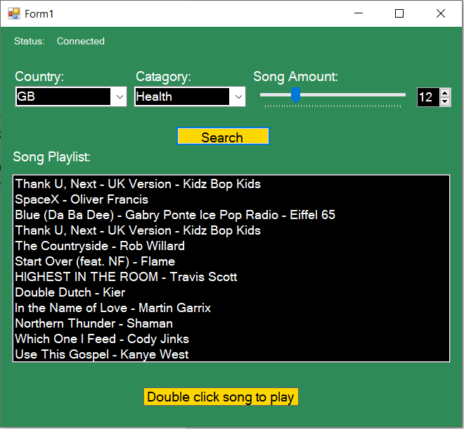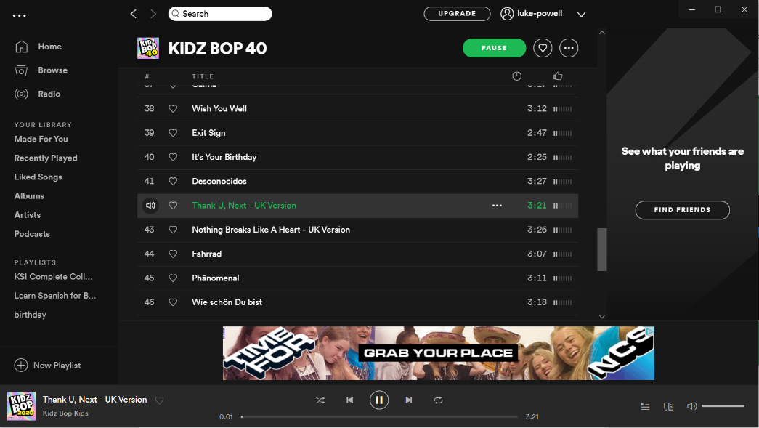Success
7. 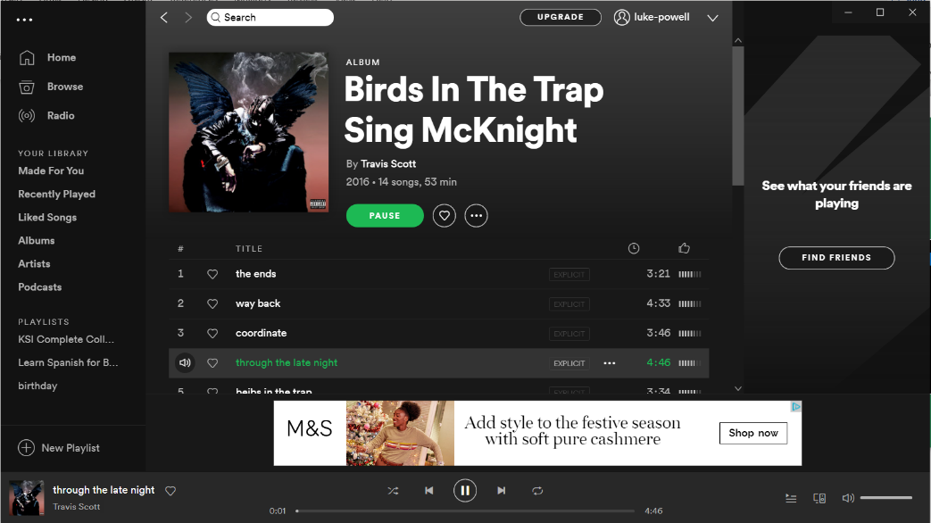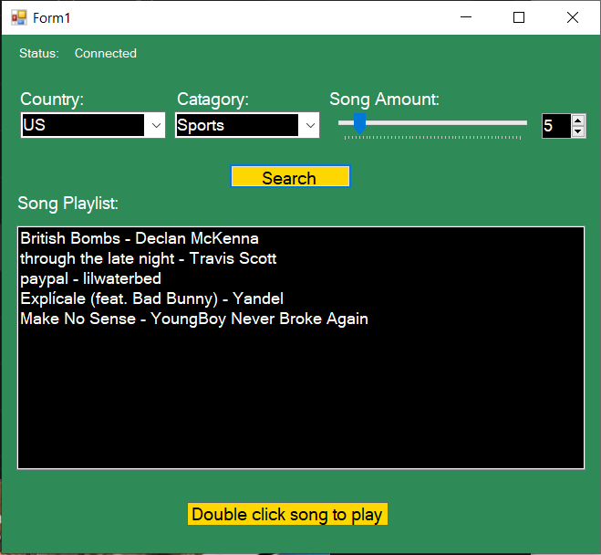 Success
8. 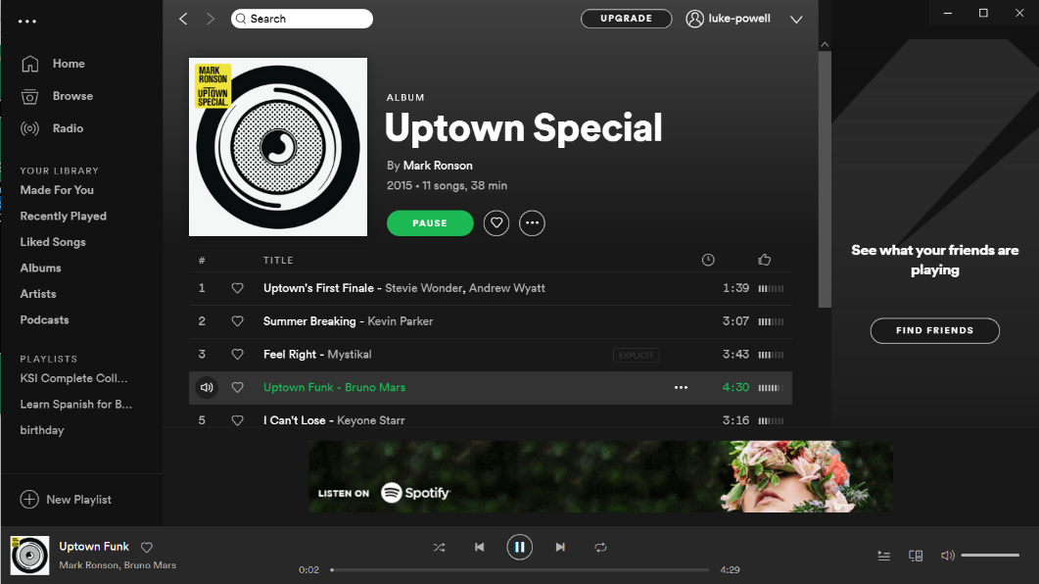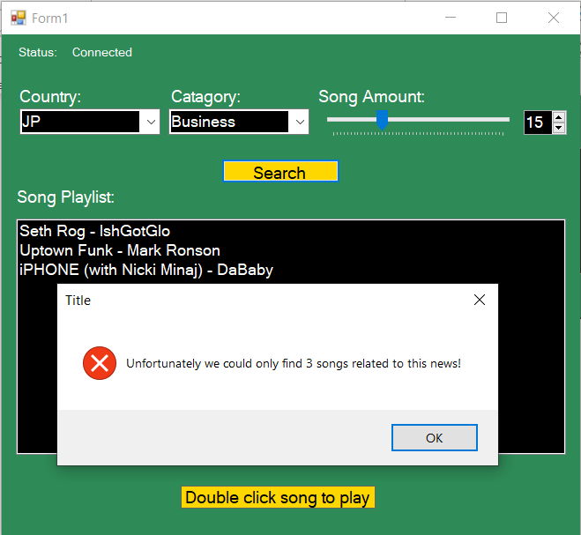 Success
9. 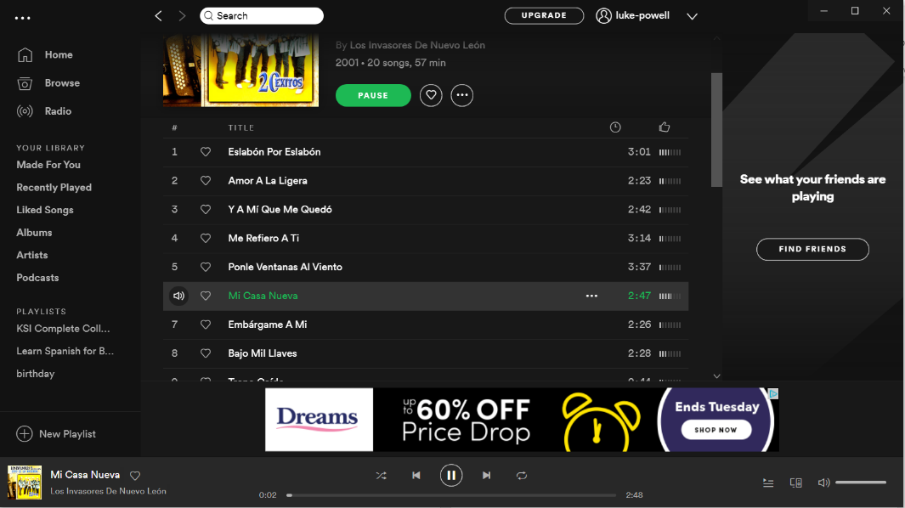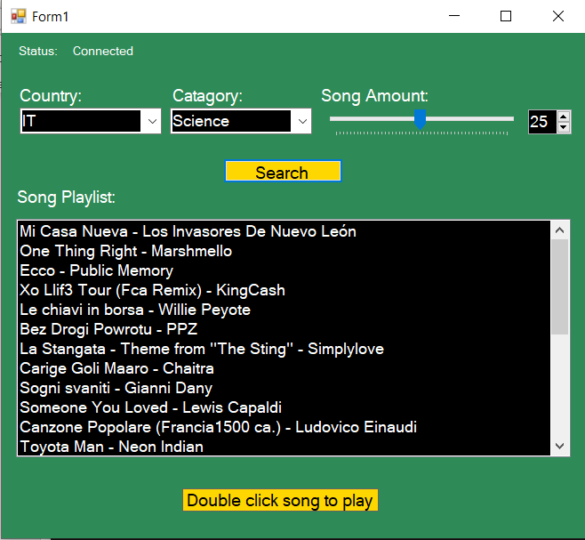 Success
10. 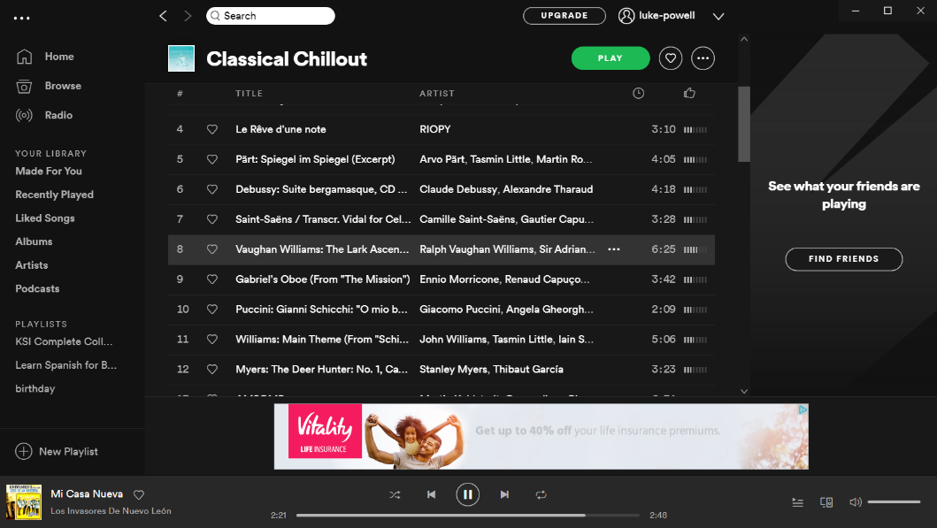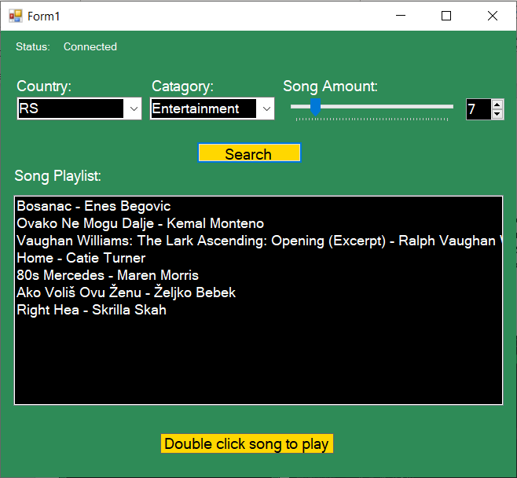 Success